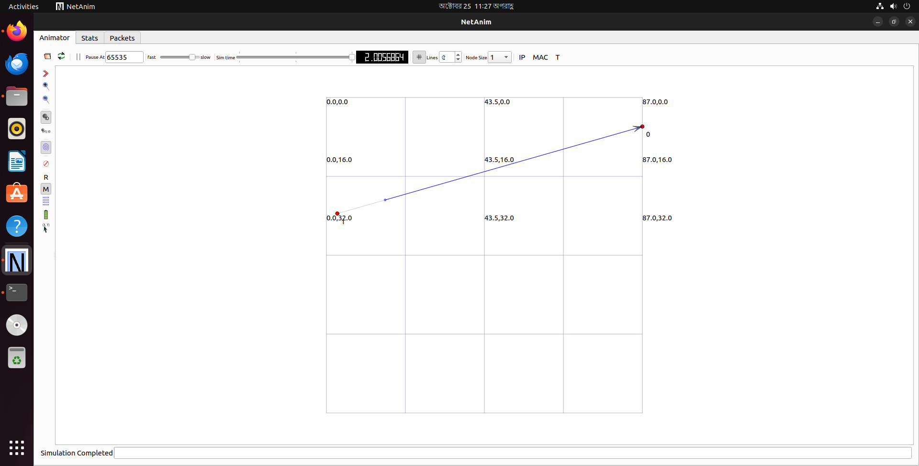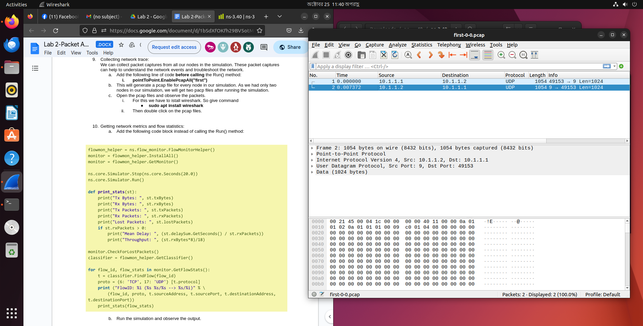

This is for frame 2. 1054 bytes of data were in the wire that were captured and the protocol was P2P. The data went from port 9 to port 49153.

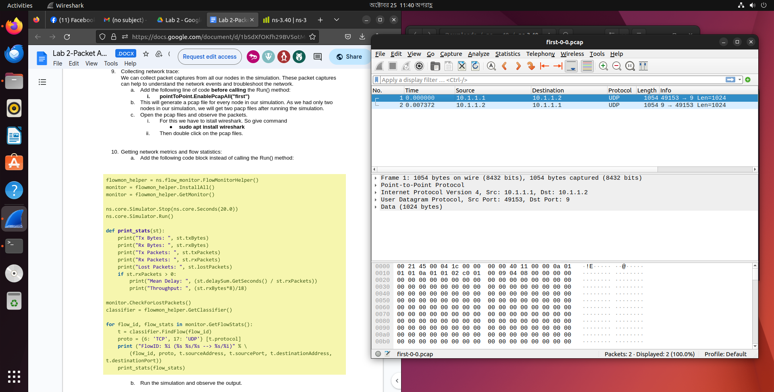

This is for frame 1. 1054 bytes of data were in the wire that were captured and the protocol was P2P. The data went from port 49153 to port 9.